**Challenge-4**

1. **Create one Declarative pipeline job**

# <https://github.com/sunil-th/sunil-app.git>

# Jenkins Setup for Your Jenkinsfile

### 1. ****Install Required Plugins****

Go to **Manage Jenkins → Plugins** and ensure these are installed:

* **Pipeline** (Declarative + Scripted)
* **Pipeline Utility Steps** (for readMavenPom, findFiles)
* **Nexus Artifact Uploader**
* **SonarQube Scanner for Jenkins**
* **Slack Notification**

### 2. ****Configure Global Tools****

**Manage Jenkins → Global Tool Configuration**

* **Maven:**
  + Name: MVN_HOME (matches your Jenkinsfile)
  + Install automatically or point to /usr/share/maven
* **SonarQube Scanner:**
  + Name: sonar_scanner (matches your Jenkinsfile)
  + Provide installation path or let Jenkins auto-install

### 3. ****Add Server Integrations****

**a) SonarQube**

* Go to **Manage Jenkins → Configure System → SonarQube servers**
  + Name: sonarqube-server (matches your Jenkinsfile)
  + Add Server URL (e.g., http://<sonar-host>:9000)
  + Add authentication token (create in SonarQube UI → My Account → Security → Tokens)

**b) Slack**

* Go to **Manage Jenkins → Configure System → Slack**
  + Workspace: your Slack team domain
  + Integration token (from Slack App)
  + Default channel: #jenkins-integration
* Test connection to ensure Jenkins can post.

### 4. ****Set Credentials****

**Manage Jenkins → Credentials → System → Global credentials**

Add the following IDs (must match your Jenkinsfile):

* **Nexus-server**
  + Type: Username with password
  + Username: Nexus repo user
  + Password: Nexus repo password
* **tomcat**
  + Type: Username with password
  + Username: Tomcat manager user
  + Password: Tomcat manager password

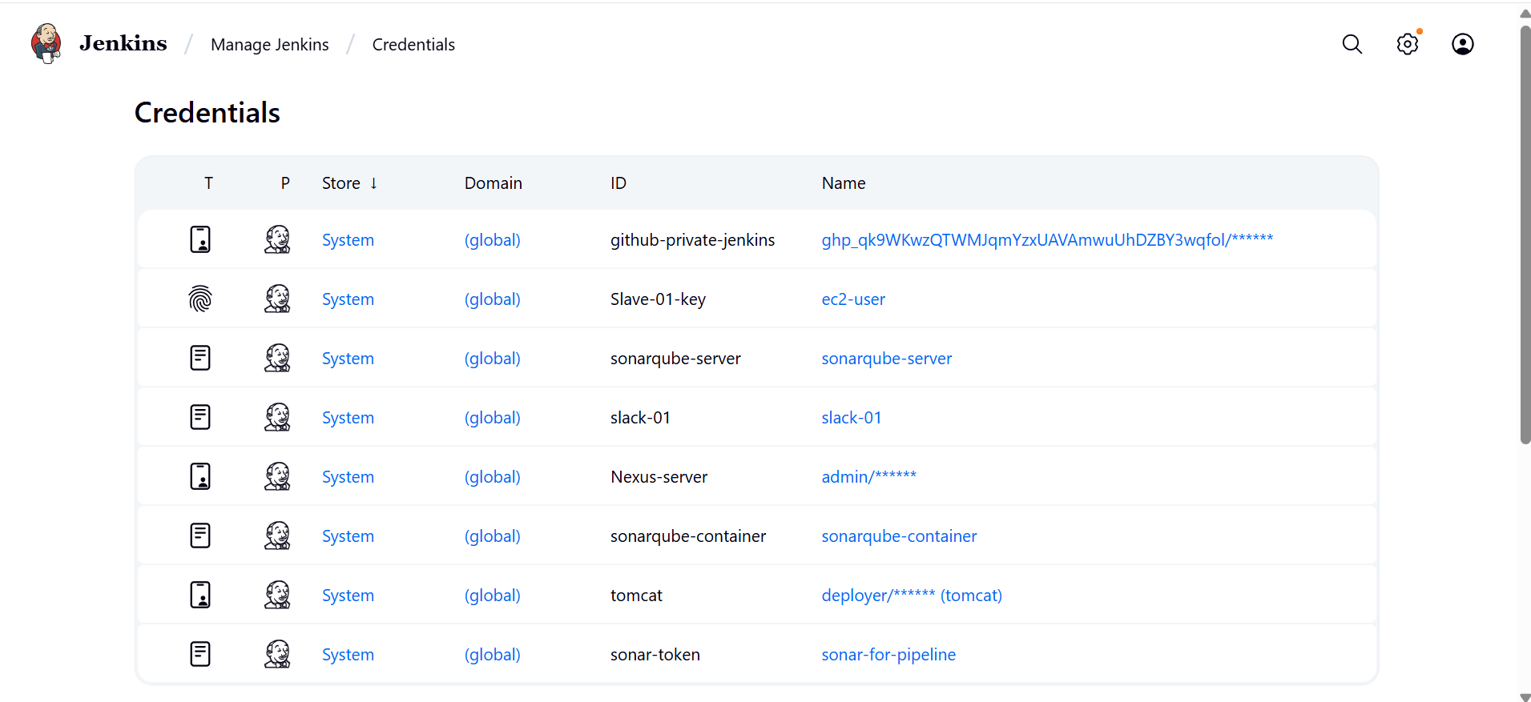

**5.Create a New Pipeline Job**

1. Open Jenkins dashboard → **New Item**.
2. Enter a job name (e.g., simple-customerapp-pipeline).
3. Select **Pipeline** → Click **OK**.

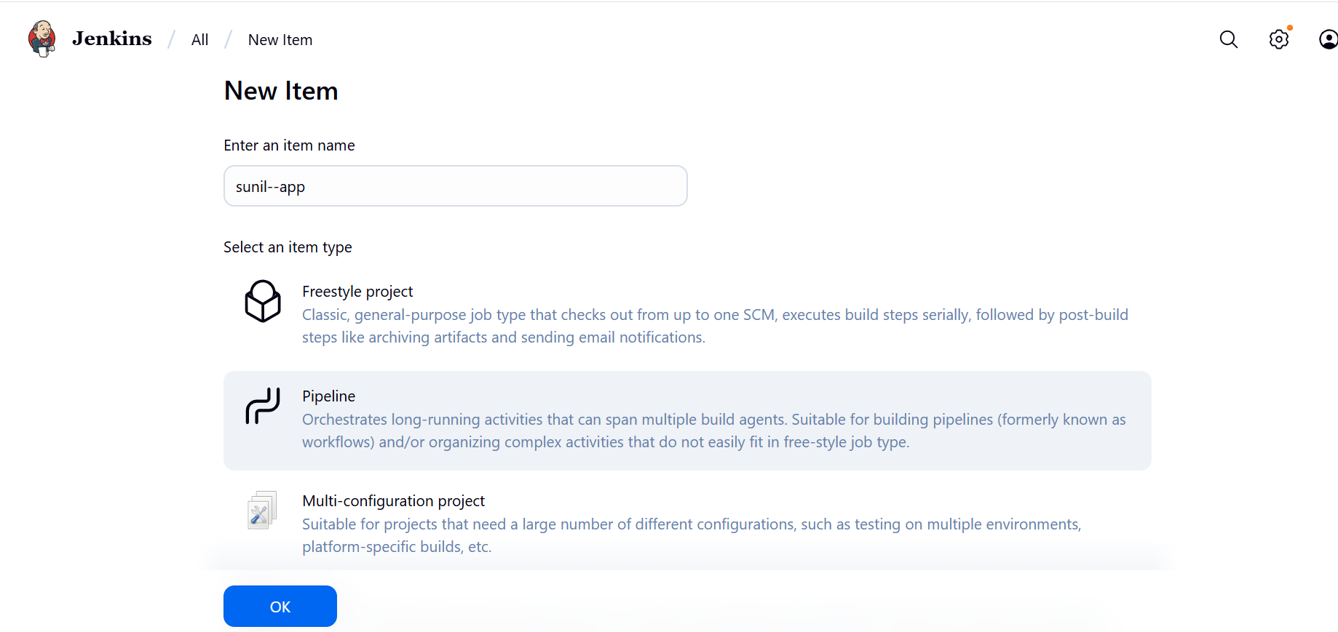

**Pipeline from SCM**

* **SCM:** Git
* **Repository URL:** https://github.com/betawins/sabear_simplecutomerapp.git
* **Branch Specifier:** */main

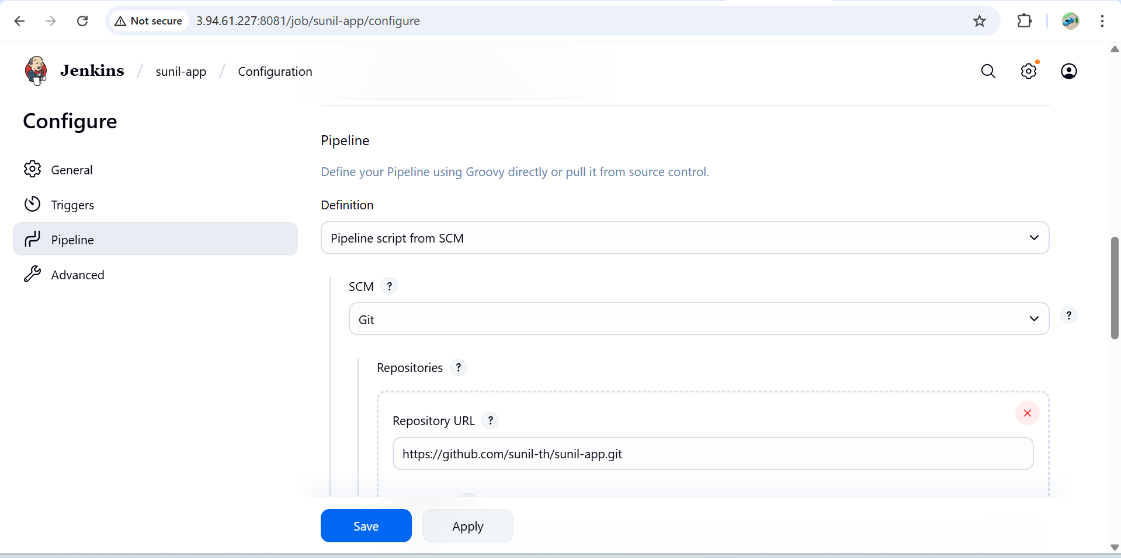

**Drop this** Jenkinsfile **into the repo**

Stages: **Git Clone → SonarQube → Maven Compile → Nexus Upload → Deploy on Tomcat → Slack**

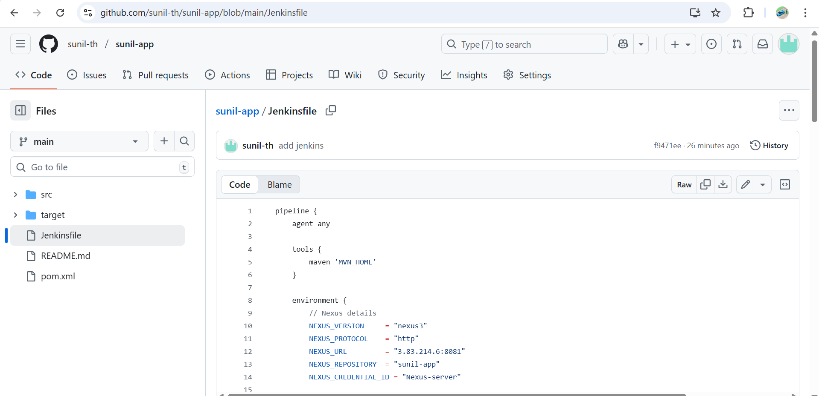

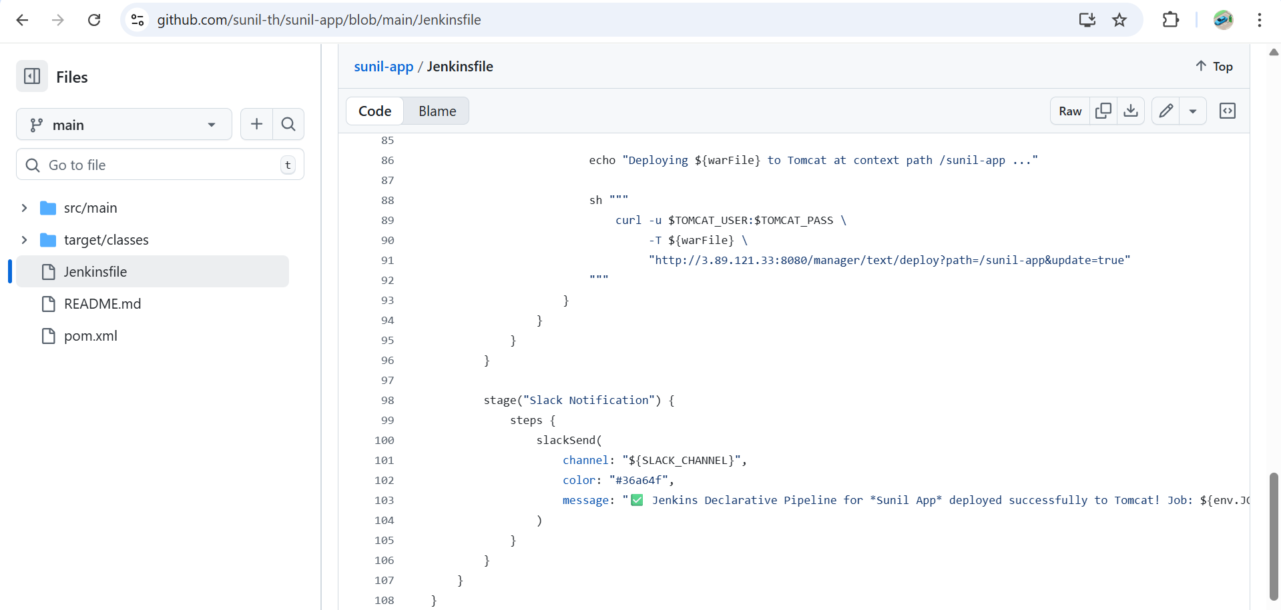

# How the Stages Work After Setup

1. **Clone Code**
   * Uses Jenkins Git plugin, no creds required since repo is public.
2. **Maven Build**
   * Compiles + packages the WAR, ignores test failures.
3. **SonarQube Scan**
   * Runs sonar-scanner CLI with your provided parameters.
   * Uses the sonarqube-server config and scanner tool.
4. **Publish to Nexus**
   * Reads pom.xml → finds WAR in target/
   * Uploads artifact + POM to Nexus repo pipe-snapshots at http://3.83.214.6:8081
5. **Deploy to Tomcat**
   * Grabs WAR file, extracts context name from filename,
   * Deploys to Tomcat Manager (http://3.89.121.33:8080/manager/text/deploy)
6. **Slack Notification**
   * Posts green success message with Job & Build info in #jenkins-integration

# Validation Checklist

Before running:

* Can Jenkins reach **SonarQube**, **Nexus**, and **Tomcat** (firewall rules)?
* Does the **Tomcat Manager app** run at http://3.89.121.33:8080/manager/html?
* Does nexusArtifactUploader show up in Jenkins pipeline syntax generator (proof plugin installed)?
* Run mvn clean install locally to ensure it builds a WAR in target/.

#### ****Save and Build****

* Click **Save**.
* Run the job → Click **Build Now**.
* Check console output to verify pipeline execution.

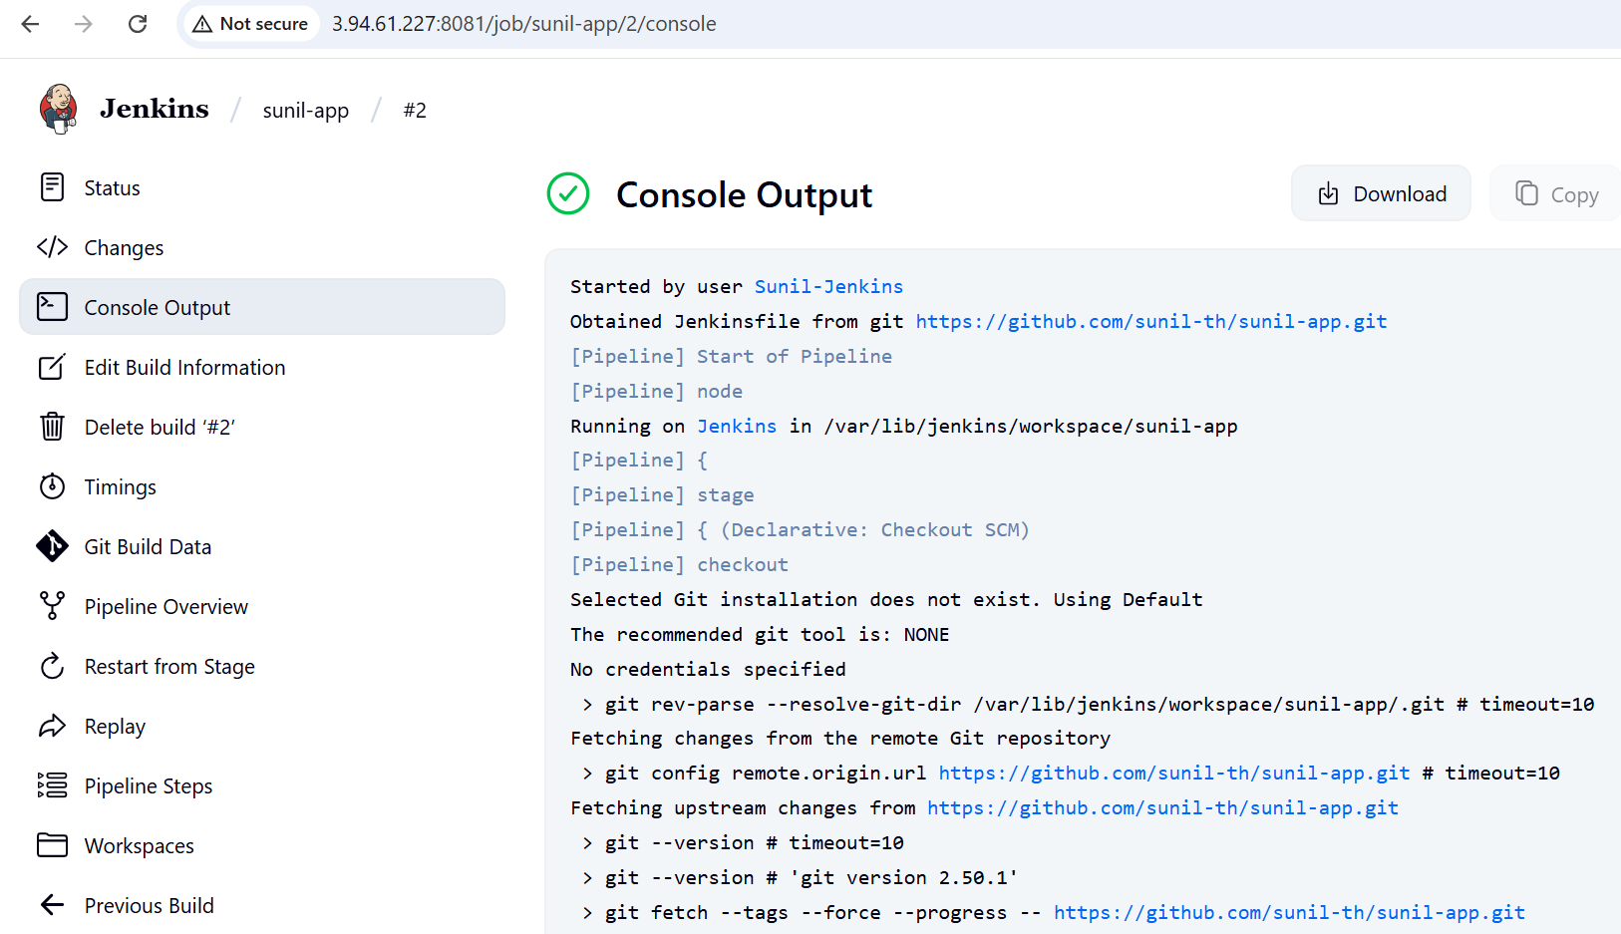

**Pipeline Flow**

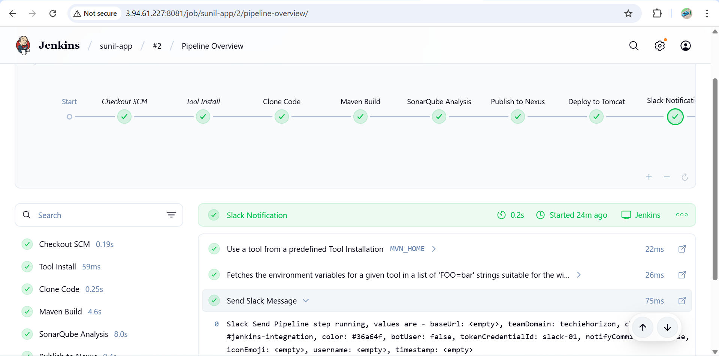

**SonarQube**

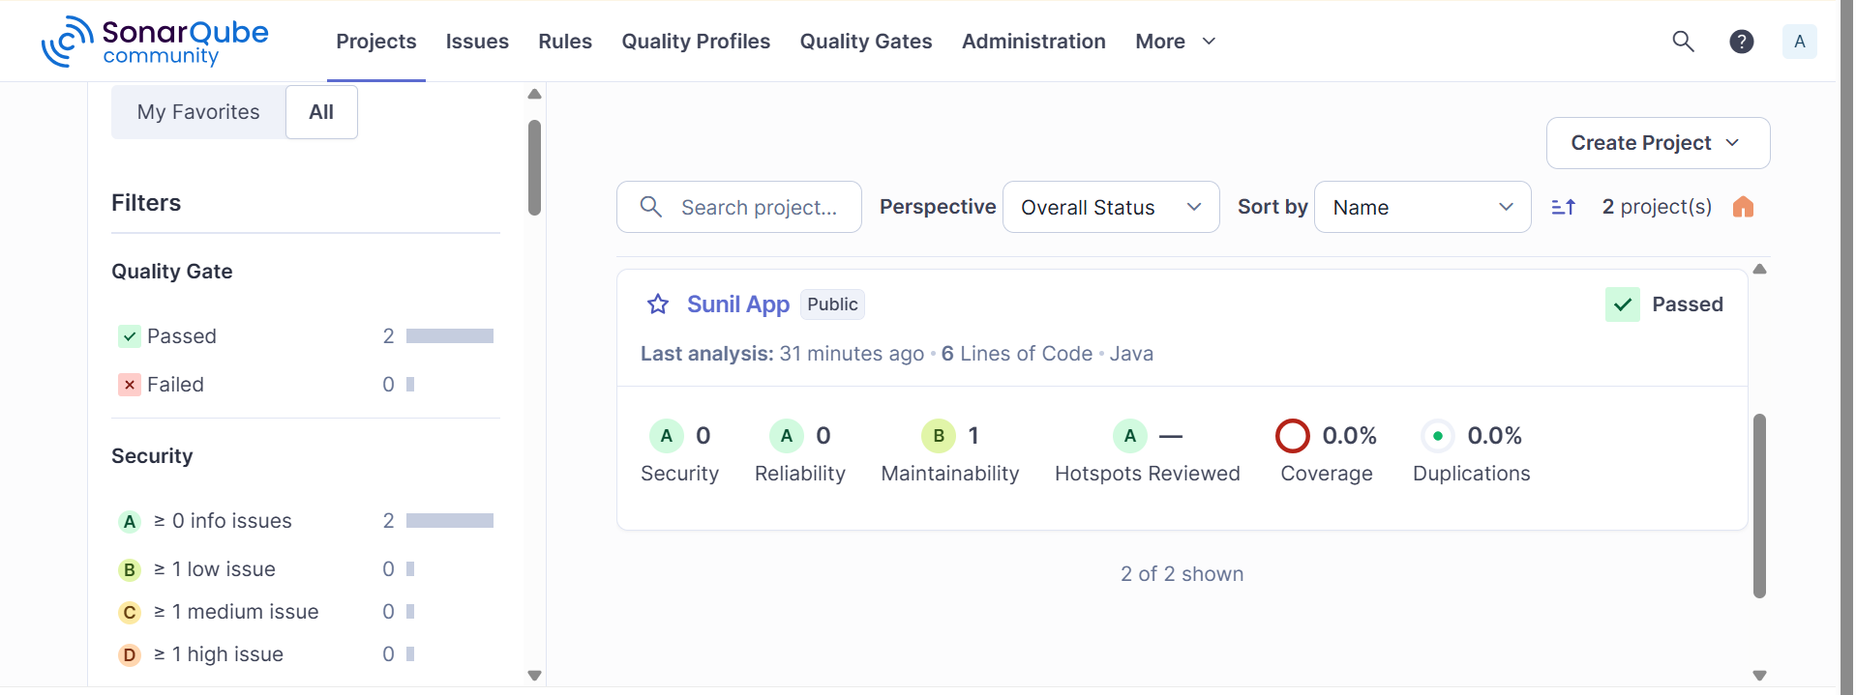

**Nexus**

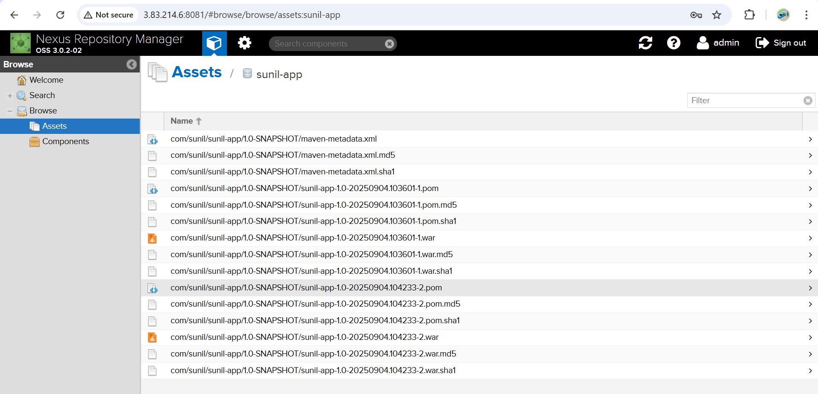

**Tomcat Deploy**

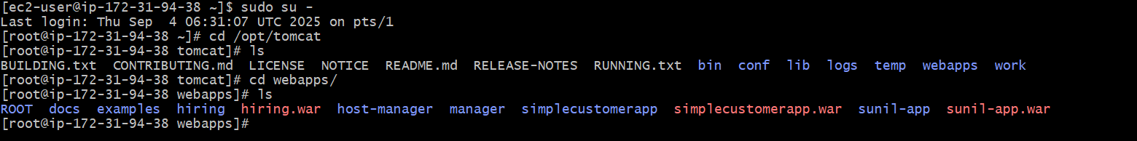

**Check the slack**

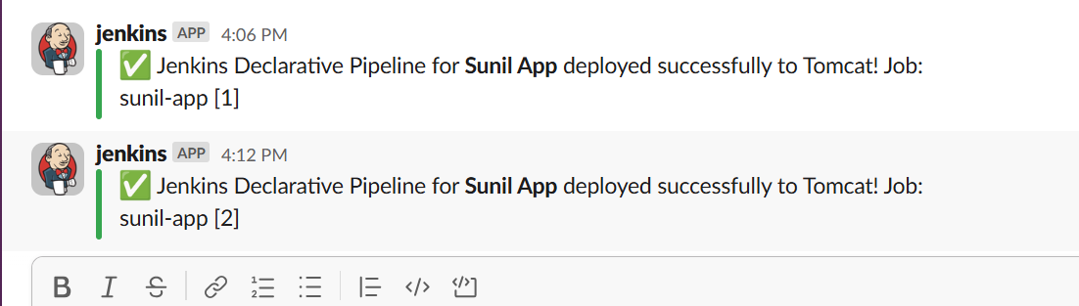

Check on the web with the public ip and the deployed file name

<http://3.89.121.33:8080/sunil-app/>

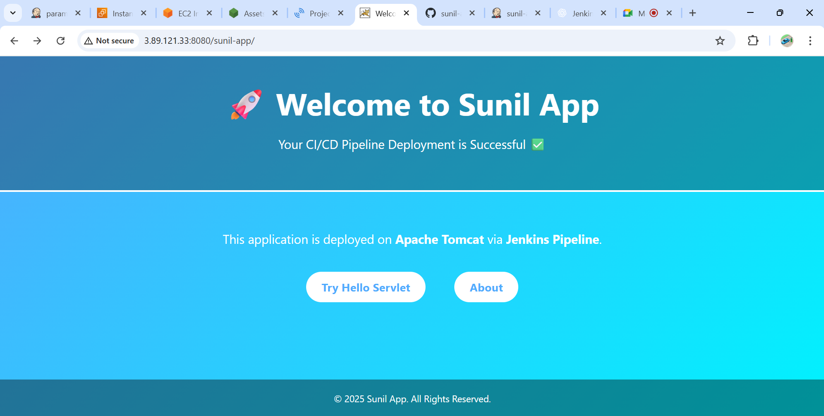

1. **Create one Scripted pipeline job**

### Steps to Create a Scripted Pipeline in Jenkins

#### ****1. Log in to Jenkins****

* Open Jenkins in your browser (http://<jenkins-server>:8080/).
* Log in with your credentials.

#### ****2. Create a New Pipeline Job****

* From Jenkins Dashboard → Click **“New Item”**.
* Enter a **name** for your job (e.g., My-Scripted-Pipeline).
* Select **Pipeline** and click **OK**.

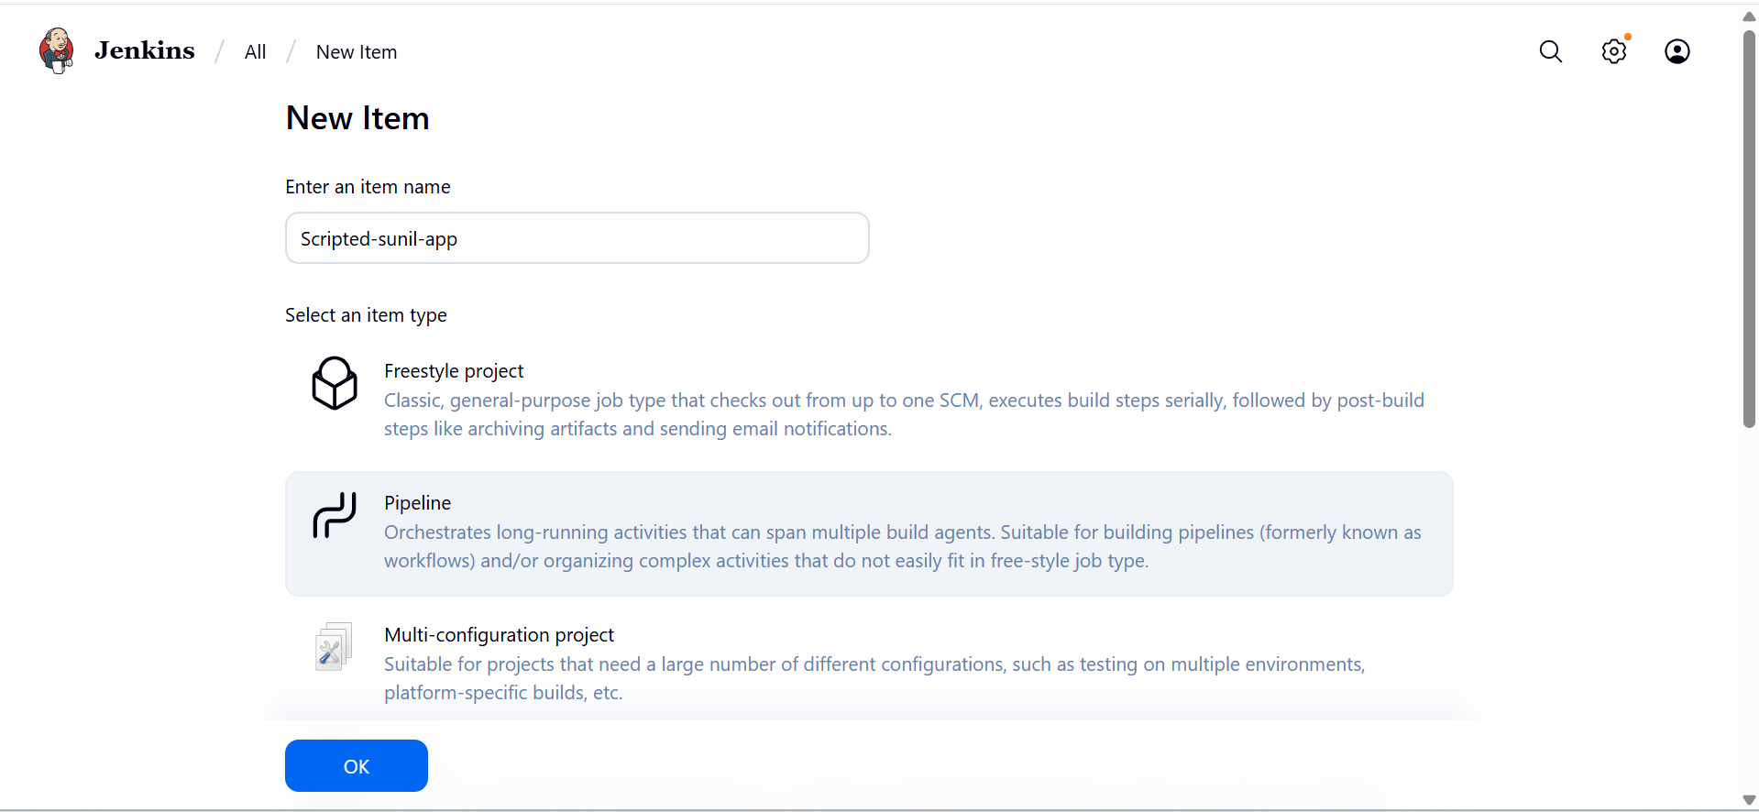

#### ****3. Configure Source Code Management (SCM)****

* In the job configuration:
  + Go to **Pipeline → Definition**.
  + Choose one of the two approaches:
    - **Pipeline script from SCM** (if your Jenkinsfile is already in your repo).
    - **Pipeline script** (if you want to write or paste the Scripted
    - Pipeline directly in Jenkins).

#### ****4. Scripted Pipeline Structure****

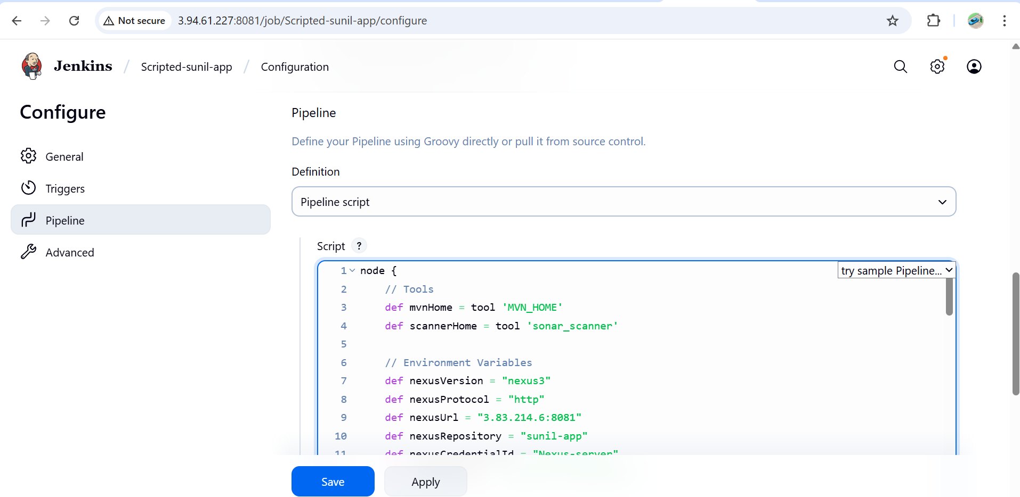

#### ****5. Save and Build****

* Click **Save**.
* Run the job → Click **Build Now**.

Check console output to verify pipeline execution

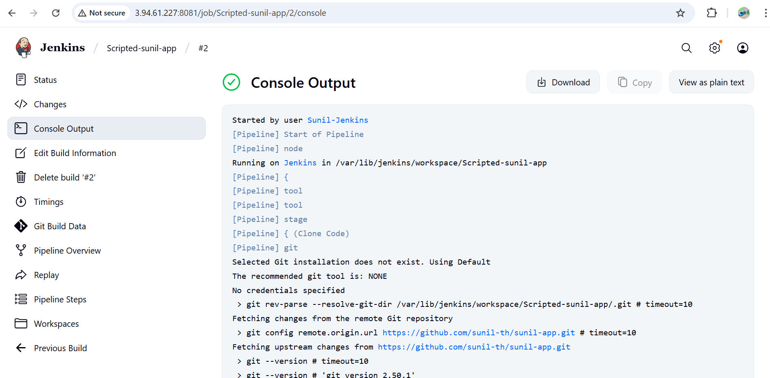

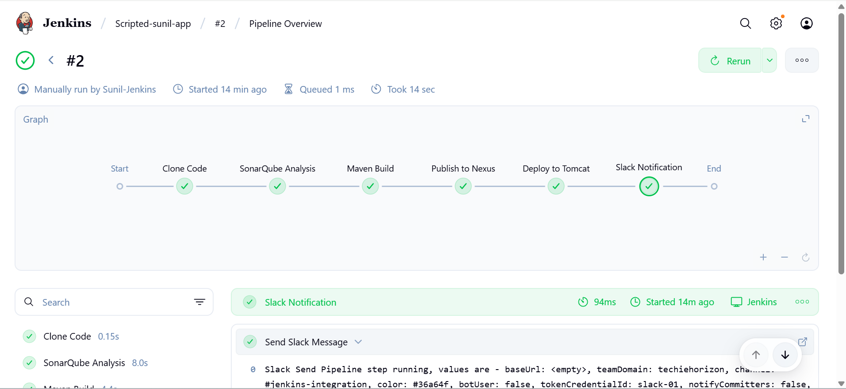

Slack Notification

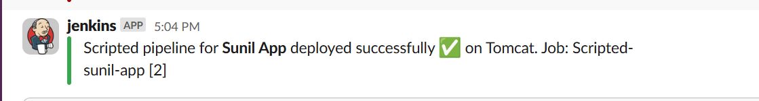

Remove the sunil-app file from web apps before you run because that app from declarative and check

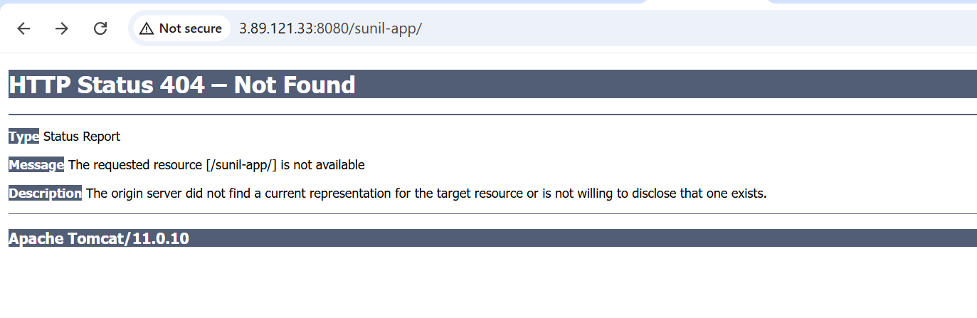

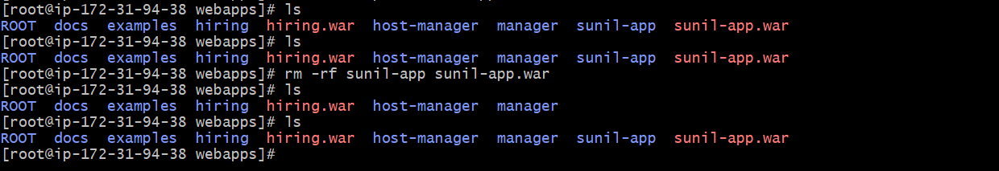

After that run the scripted pipeline and check

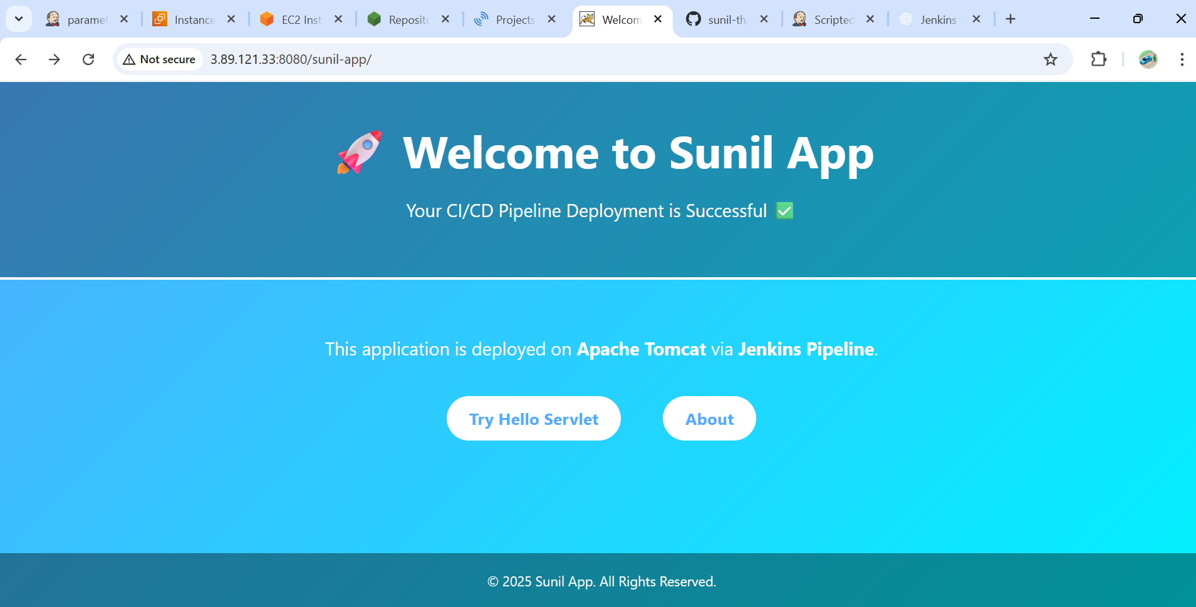

1. **Create one multi stage pipeline job**

### 1. Login to Jenkins

* Open Jenkins in your browser (usually http://<jenkins-server>:8080).
* Login with your credentials.

### 2. Create a New Pipeline Job

1. Click on **"New Item"**.
2. Enter a job name, e.g., MultiStage-Pipeline.
3. Select **Pipeline**.
4. Click **OK**.

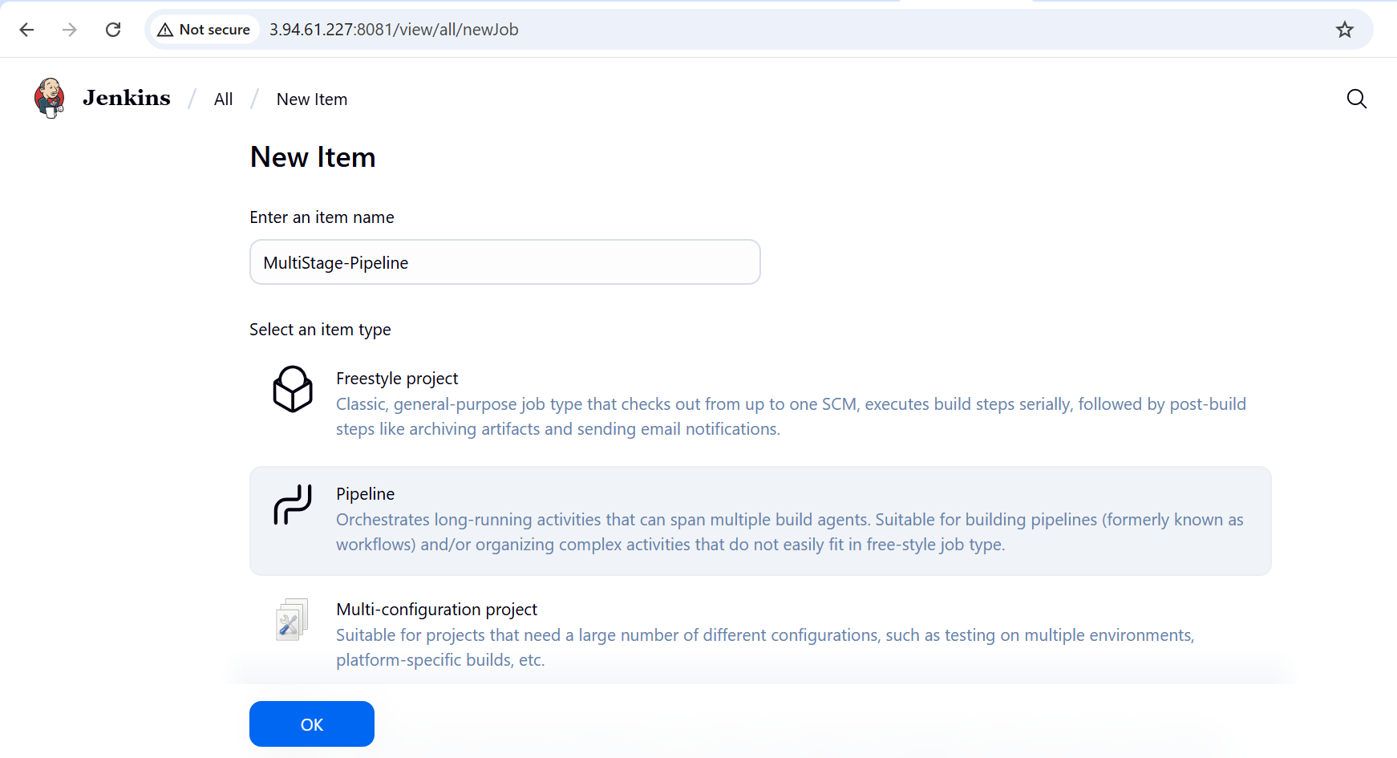

### 3. Configure the Job

* Scroll down to **Pipeline** section.
* Choose **Pipeline script** (or use Jenkinsfile from SCM if you want Git integration).
* I used scm here declarative syntax for multistage pipeline

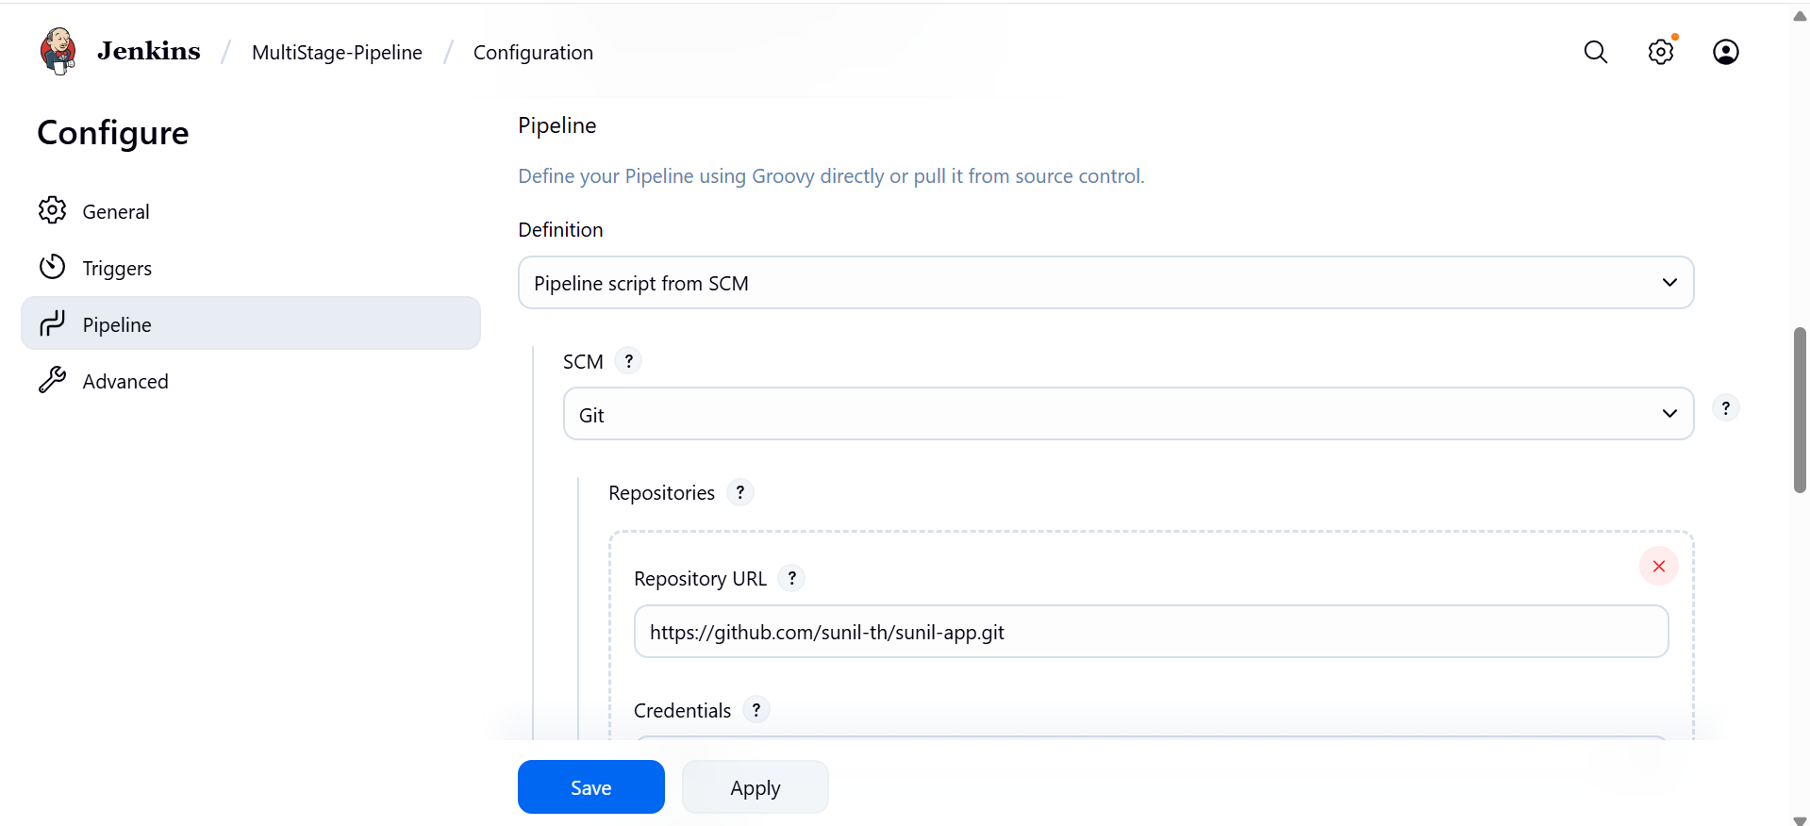

Mention the branch name in which branch you are adding the Jenkinsfile

And also script path give the file name in which you kept yourcode--Jenkinsfile

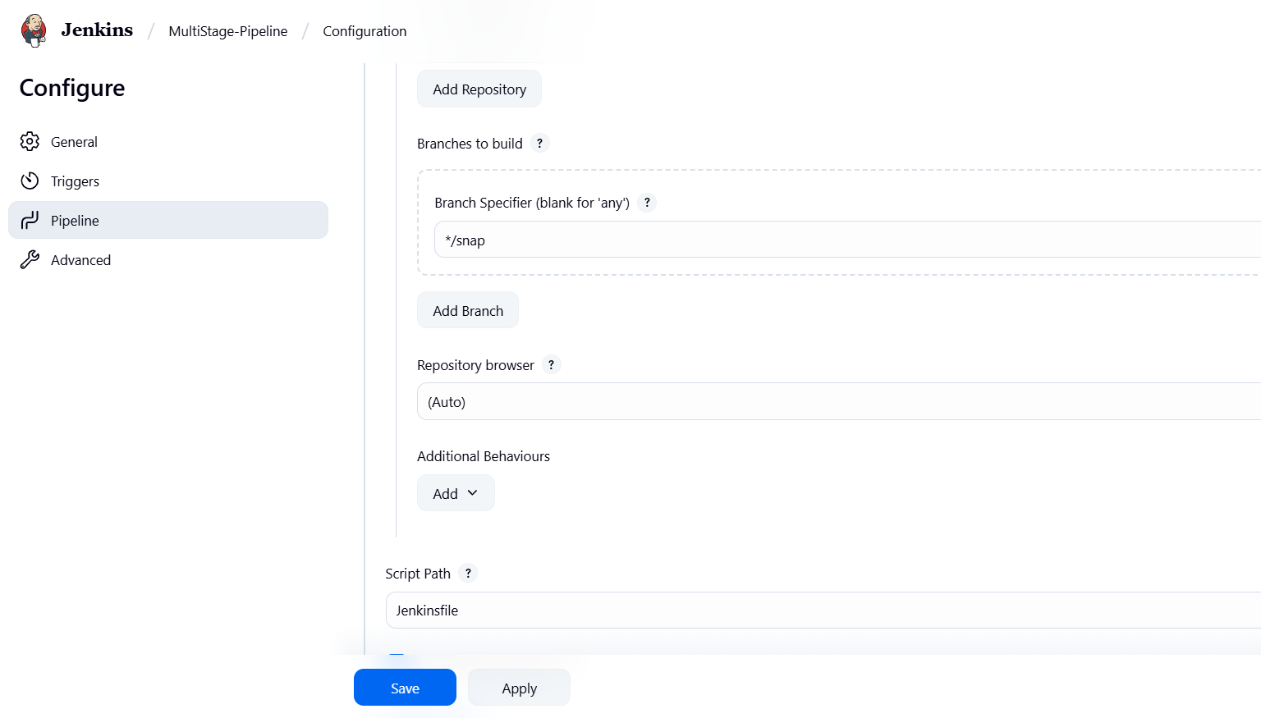

**Drop this** Jenkinsfile **into the repo**

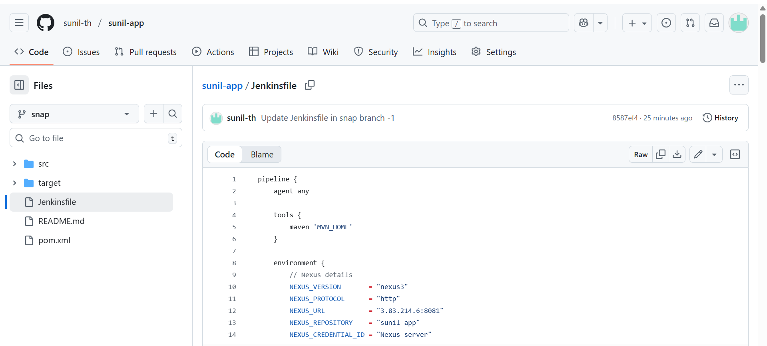

### 5. Save & Build

* Click **Save**.
* Run **Build Now**.
* You’ll see multiple **stages** in Jenkins UI (Git Clone → Build → Code Analysis → Test → Package → Deploy).

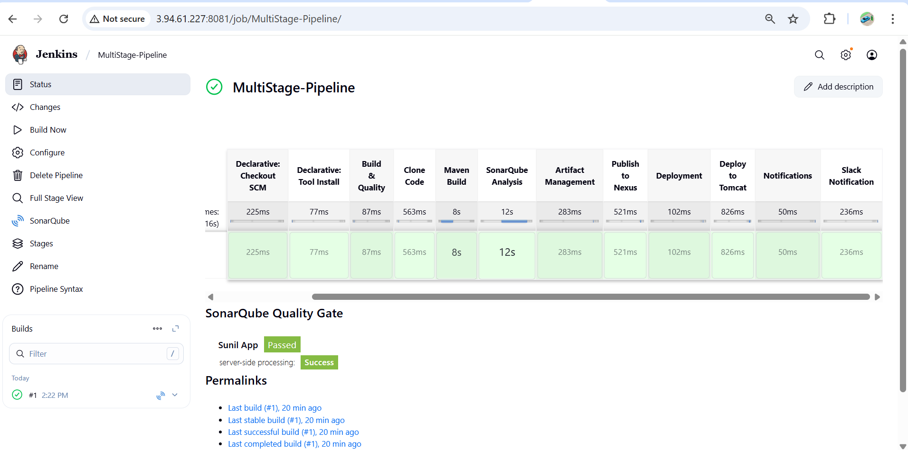

Multistage-PipeLine

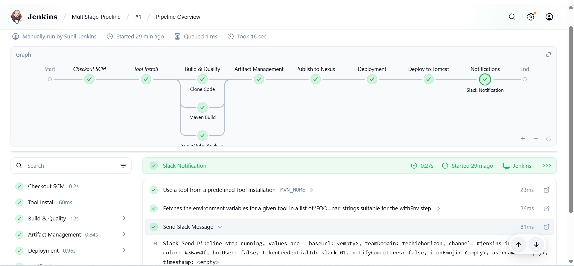

**Slack:**

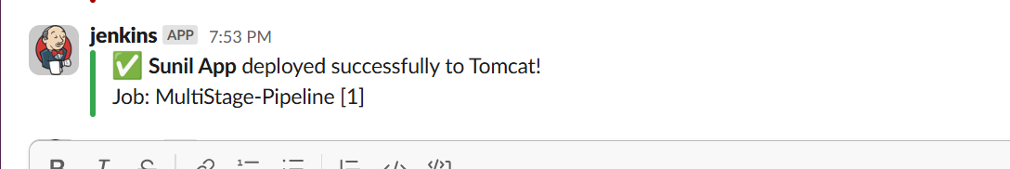

## ****Multi-Stage Pipeline****

* **Definition:** A pipeline divided into **multiple stages**, where each stage represents a step like Build, Test, Deploy.
* **Focus:** Structure and visualization of the workflow.
* **Can be implemented in both Declarative and Scripted syntax.**
* **Key Point:** “Multi-stage” refers to **the organization of the workflow**, not the syntax itself.

Example: Build → Test → Deploy is a **multi-stage pipeline**.

| * Feature | * Multi-Stage Pipeline | * Declarative Pipeline | * Scripted Pipeline |
| --- | --- | --- | --- |
| * Definition | * Pipeline with multiple stages | * Structured, readable Jenkins syntax | * Flexible, code-oriented syntax |
| * Purpose | * Organize workflow visually | * Easier to maintain and read | * Handle complex logic dynamically |
| * Syntax | * Can be declarative or scripted | * pipeline { stages { ... } } | * node { stage('...') { ... } } |
| * Complex Logic | * Usually simple sequential steps | * Limited, but sufficient for most CI/CD | * Very flexible, supports loops/conditions |
| * Recommended For | * Any pipeline needing stages | * Teams/new users | * Advanced users/complex pipelines |

**Summary:**

* **Multi-stage pipeline** = concept of dividing your workflow into stages (Build, Test, Deploy).
* **Declarative vs Scripted** = **syntax choices** to implement a pipeline.
* Declarative is **simpler and structured**, scripted is **more flexible and code-heavy**.
* Multi-stage pipelines are **usually written in declarative syntax** because it’s clearer, but can also be scripted.

1. **Create one parallel stage pipeline job**

Steps to Create a Parallel Pipeline Job

**Login to Jenkins**

* Open Jenkins (http://<jenkins-server>:8080) and log in.

**Create a New Pipeline Job**

* Click **New Item**.
* Enter a name (e.g., Parallel-Pipeline).
* Select **Pipeline** and click **OK**.

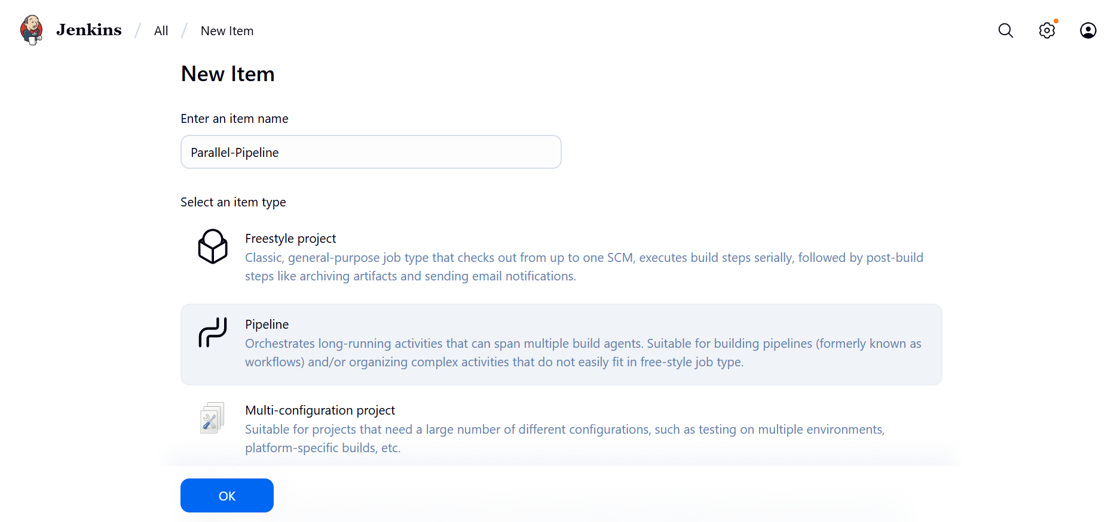

**Configure the Pipeline**

* Scroll to the **Pipeline** section.
* Choose one of these:
  + **Pipeline script** → Paste your pipeline code directly.
  + **Pipeline script from SCM** → Fetch pipeline code (Jenkinsfile) from Git.

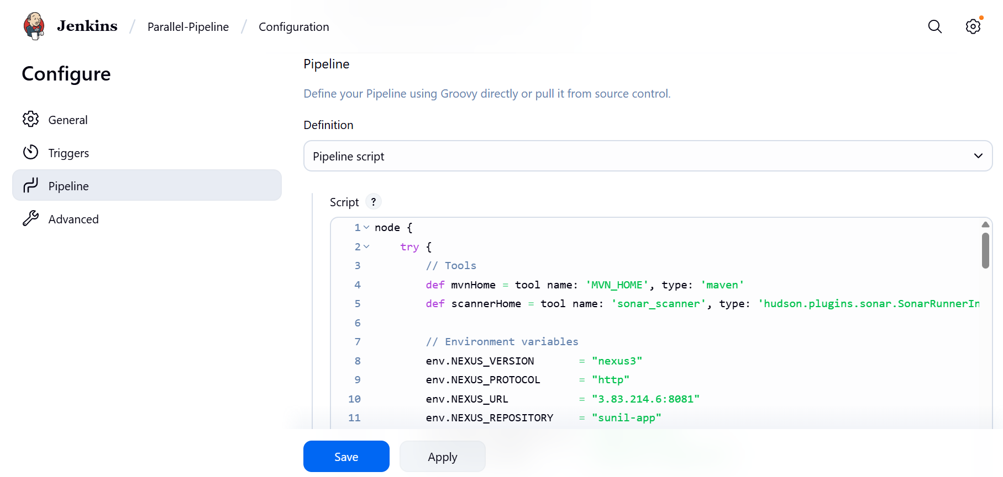

**Define Parallel Stages**

* Inside your pipeline, add a parallel {} block under a stage.
* Each branch inside parallel {} runs **at the same time**.

**Save and Build**

* Click **Save**.
* Click **Build Now**.

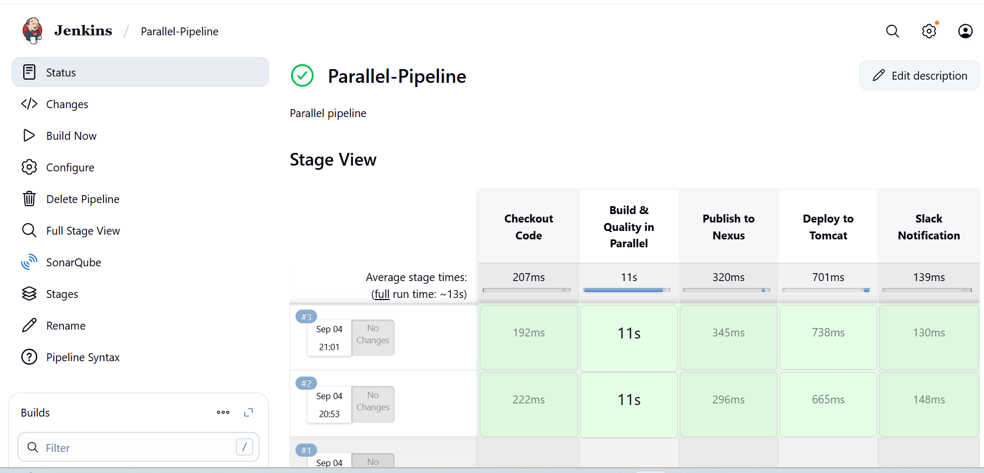

**View Results**

* Open the build.
* In Jenkins UI

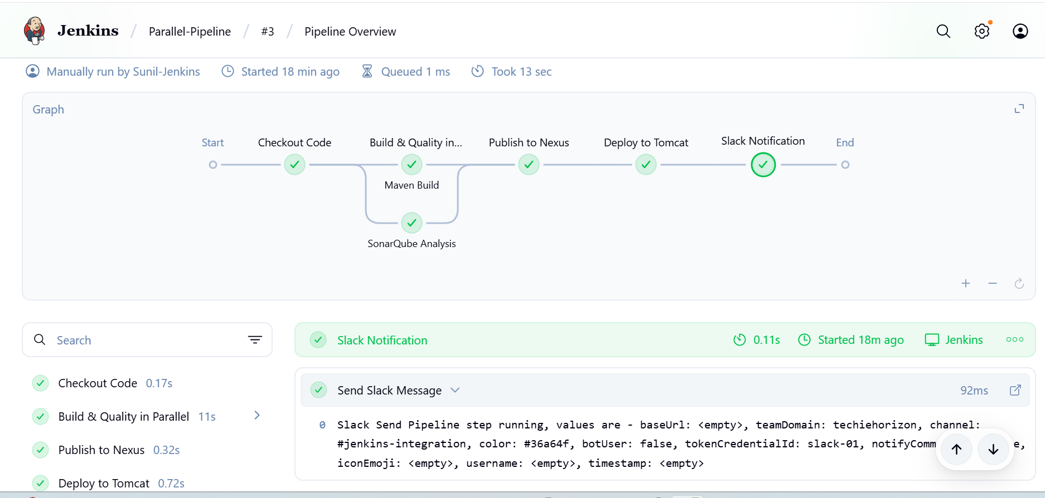

**Slack:**

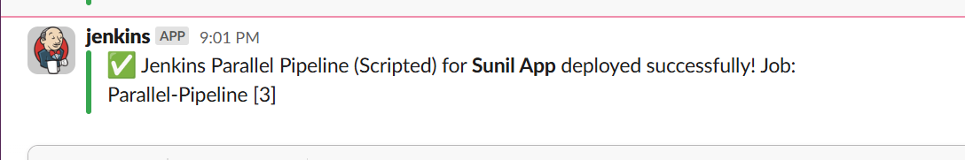

**Tomacat Deploy**

